## Tech stack

### Data analysis

   

* Excel
* Python

### Data visualisation

 

* Tableau

## Skills showcased

Demonstrated 6 key skills through this micro experience

1. Programming skills: I utilized Python for dataset merging and cleaning, ensuring the data was consolidated and free from inconsistencies and errors.
2. Data Visualization: I employed data visualization techniques to illustrate the sales funnel, displaying lead progression across stages and conversion rates effectively.
3. Data analysis: I performed data analysis on hostel accommodation data, calculating conversion rates and generating percentages to track leads' progression through the sales funnel.
4. Problem solving and critical thinking: I applied problem-solving and critical thinking skills to address challenges, analyze situations, and devise effective solutions through thoughtful and logical reasoning.
5. Communication and storytelling: I crafted a visually engaging PowerPoint presentation to effectively communicate information, convey a compelling narrative, and captivate the audience.
6. Business acumen: Leveraging my business acumen, I analyzed the sales funnel for the Hostel chain, identifying bottlenecks, optimizing opportunities, measuring conversion rates, and providing revenue-maximizing recommendations.

## Problem scenario

### Situation

**Business Situation:** SAPL faced a low conversion rate of 13% despite a surge in leads during the admission season.

**Business Process:** Analyzing various stages of student acquisition to identify factors causing the drop in conversions.

**Importance**: Understanding the reasons behind low conversion rates is crucial for optimizing business performance and maximizing revenue generation.

### Complication

**Process delay**: Leads were not contacted within the specified time frame, resulting in missed business opportunities.

**Missed opportunities**: Leads should have been promptly contacted to identify and capitalize on hot leads.

**Conversion rate challenge**: Addressing the low conversion rate by analyzing the funnel stages and optimizing lead contact strategies.

### Business impact

**Negative Impact**: Decreased conversion rate and missed business opportunities due to delayed lead contact.

**Most Impacted**: SAPL’s business performance and revenue generation.

**Affected Metrics**: Conversion rate, lead-to-customer ratio, and overall revenue potential.

## Objectives

Success looks like an improved conversion rate, increased lead-to-customer ratio, and optimized revenue generation for SAPL.

## Approach

1. **Problem approach**
   1. **Business Process Learning**: Conducted research, explored industry resources, and studied relevant materials to understand the business process and key metrics.
   2. **Problem Statement Validation**: Analyzed data, compared findings with expectations, and conducted exploratory data analysis to validate the problem statement.
   3. **Problem Narrowing**: Conducted a thorough analysis, identified patterns and trends, and prioritized the most impactful aspects of the problem.
   4. **Framework Selection**: Considered personal experience, research findings, and project requirements to choose a suitable framework for problem breakdown.
2. **Analytical approach**
   1. **Data Collection and Cleaning**: Collected and merged datasets, ensuring data quality through thorough cleaning and preprocessing techniques.
   2. **Data Exploration**: Conducted descriptive statistical analysis, visualizations, and exploratory data analysis to gain insights into the dataset.
   3. **Hypothesis Development**: Formulated hypotheses such as “The low conversion rate is due to inadequate lead follow-up.”
   4. **Assumptions**: Assumed that lead response time significantly impacts conversion rates.
   5. **Frameworks/Models**: Utilized a sales funnel analysis framework and employed statistical models such as logistic regression for analyzing conversion rates.
   6. **Key Insights**: Identified delayed lead response time as a significant factor contributing to the low conversion rate.
3. **Insights and recommendations**
   1. Conducted root-cause analysis to identify underlying factors contributing to the low conversion rate.
   2. Provided actionable recommendations, including improving customer care response time and optimizing lead follow-up processes.
4. **Solution implementation and monitoring**
   1. Defined key performance indicators (KPIs) such as conversion rate, lead progression rate to track solution effectiveness.
   2. Developed a decision support dashboard to monitor KPIs, visualize data trends, and aid in implementing the recommended solution.
5. **Communication** 
   1. I employed a combination of methods including Tableau dashboard presentation, PowerPoint presentation and concise one-pager documents to communicate with stakeholders.

## Impact created

Using the commercial calculator for partners in the Ahmedabad cluster had a significant business impact. It enabled accurate and efficient calculations of financial metrics, allowing for better decision-making, streamlined processes, and improved profitability. This tool helped optimize pricing strategies, negotiate deals, and ultimately maximize revenue and profitability for the partners in the Ahmedabad cluster.

## Project deliverables

**Process Chart**

Link: <https://github.com/aritra-18/FunnelAnalysis-LeadConversionOptimization-SAPL/blob/main/Process%20Chart.png>

Type: document

Created process map for detailed sales funnel analysis and insights

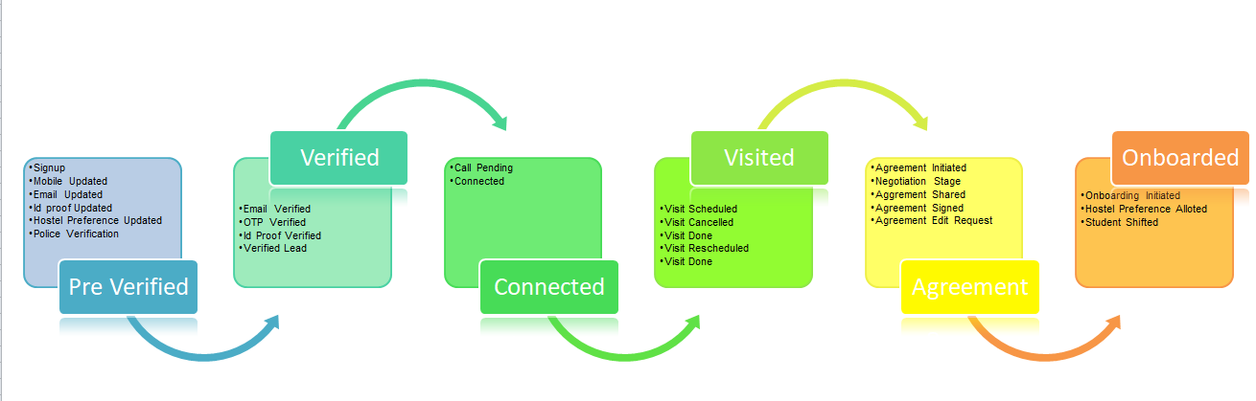

**Funnel Chart**

Link: <https://github.com/aritra-18/FunnelAnalysis-LeadConversionOptimization-SAPL/blob/main/Sales%20Funnel.png>

Type: document

Developed a crafted engaging funnel chart showcasing stages of hostel booking journey.

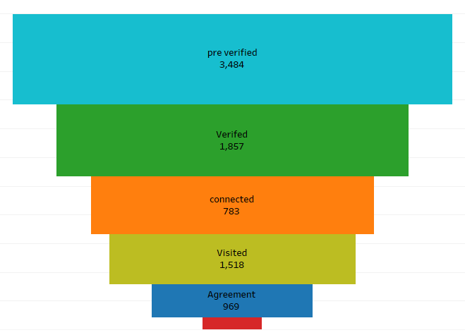

**Funnel Summary**

Link: <https://github.com/aritra-18/FunnelAnalysis-LeadConversionOptimization-SAPL/blob/main/Funnel%20Report.png>

Type: document

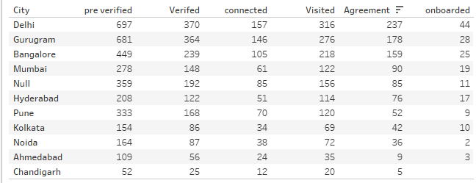

**Presentation Deck:**

Link: <https://github.com/aritra-18/FunnelAnalysis-LeadConversionOptimization-SAPL/blob/main/Analyzing%20Sales%20Funnel%20for%20a%20Student%20Hostel%20Accommodation.pptx>

Type: document

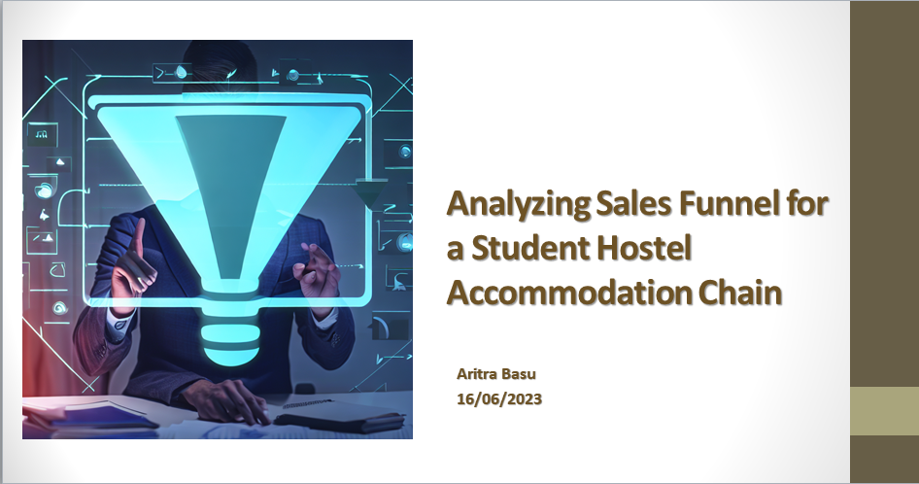

## 

## Things I learnt (optional)

1. Hands-on experience in data manipulation and analysis using Python, improving data skills.

2. Enhanced understanding of sales funnel dynamics through process mapping, identifying improvement areas.

3. Developed expertise in crafting engaging presentations and optimizing lead progression for better conversion rates.

## Feedback received (optional)

N/A